Type-C To 4-Port USB3 Hub With 2-in-1
USB/USB-C Personality Port
Enable a powerful 4-Port USB Hub with the added
convenience of a dual-personality Type-C/USB input
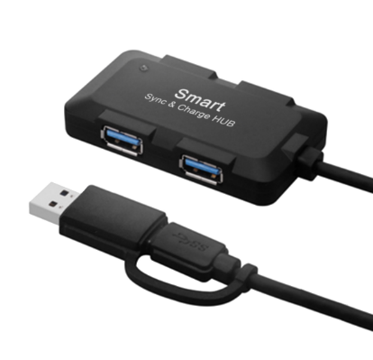

Descrption:
Combine the power of USB-C technology on your MacBookTM, WindowsTM or other digital device with an integral USB3 4-port Hub. Ideal for simultaneous connection of almost any USB device including keyboards, mice, USB storage at the same time.

A unique, Type-C, or if needed, conventional USB type input allows the hub to be used on new technology Type-C MackBookTM, WindowsTM for example as well as older legacy USB notebooks and desktop PCs. All combined in a stylish, compact and of course self-powered design.

Features:
- Data transmission rate can reach USB 3.1 10Gbps
- Ultra thin design, mini size
- Output interface: four port USB 3 HUB hub, down compatible with USB 2.0/1.2/1.0
- (widely used in apple Macbook Air 3.1 output to four USB3.0 mobile hard disk / mobile phone /U disk interface signal source connection, with OTG function, turn out is high-speed USB 3 speed)4 PORT TYPE C Hub,Product features: classic design, stay outside the persistent power, support hot plug, low power consumption. Apply to U disk,Card reader, USB mouse, USB keyboard, scanner, digital camera, digital video camera, USB sound card,Computer peripherals such as hard disks. Extended 4 USB, each mouth power supply up to 500MA, using 2 generations of USB
- HUB controller, no driver, plug and play, all use of first-class quality electronic devices.Ensure product stability.

Product Code:
- Part number: C-TC-2IN1-USB3HUB
- Product net weight: 90g
- Barcode: 8400800036667

